1. **BPO MANAGEMENT SYSTEM USE CASE DIAGRAM:**

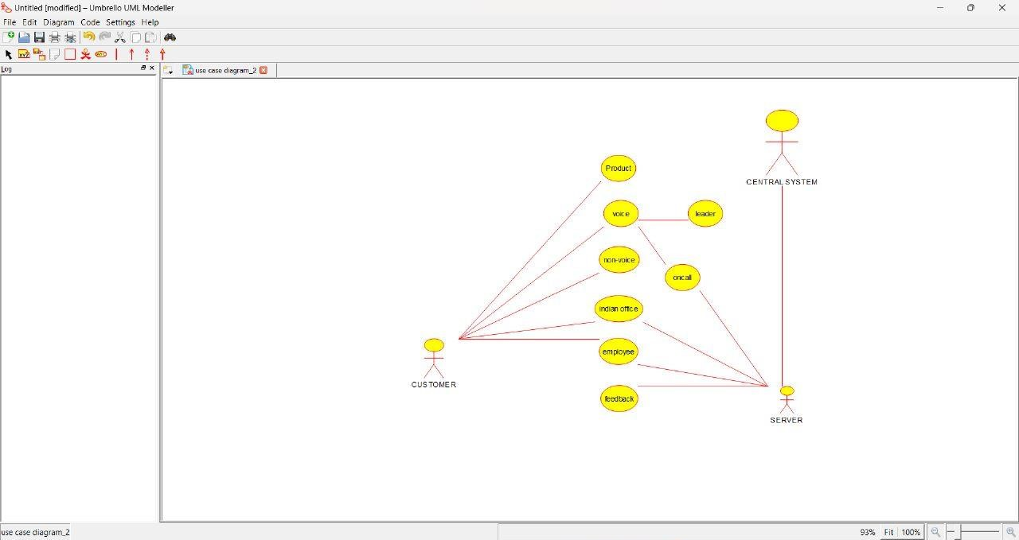

**ACTIVITY DIAGRAM:**

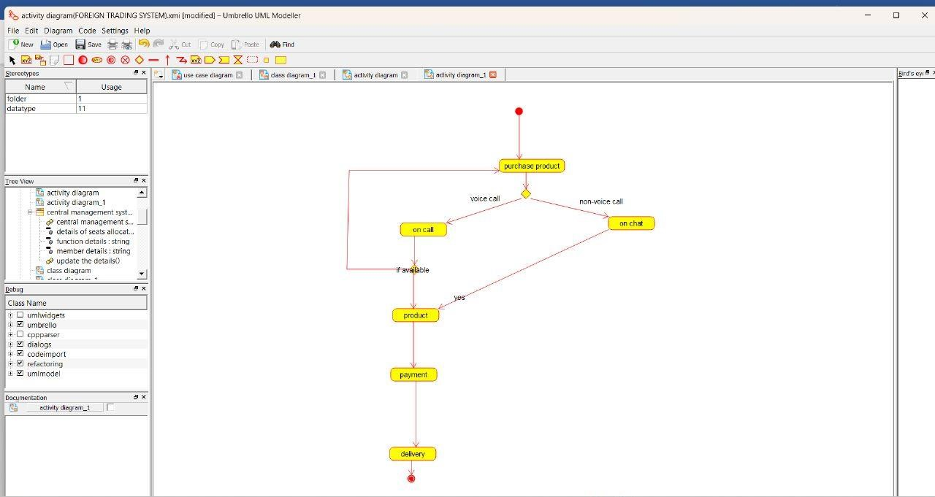

**SEQUENCE DIAGRAM:**

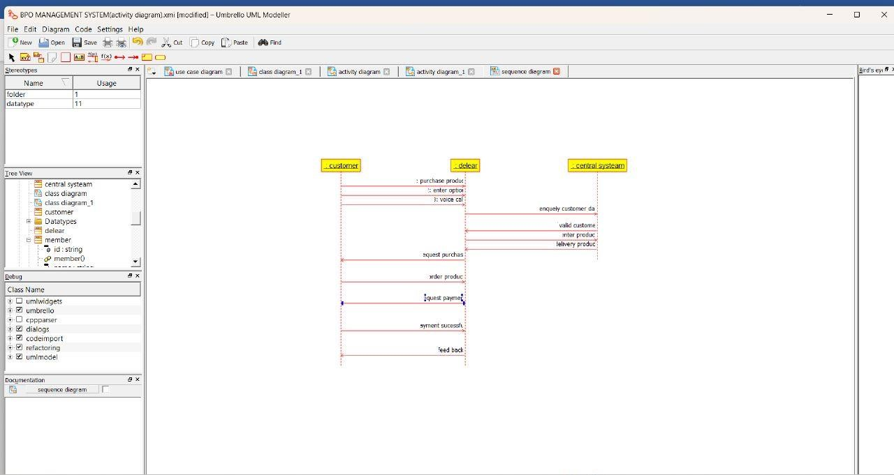

**OBJECT DIAGRAM:**

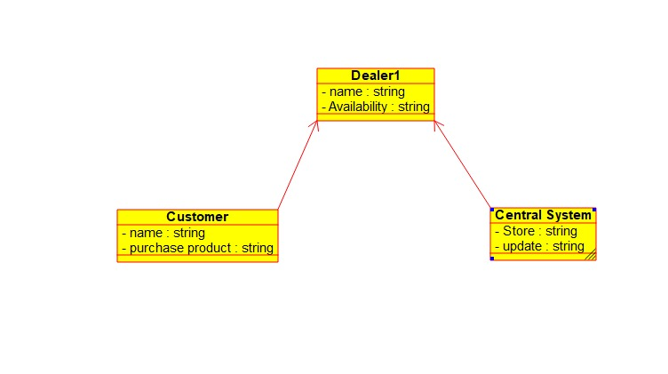

**COLLABIRATION DIAGRAM:**

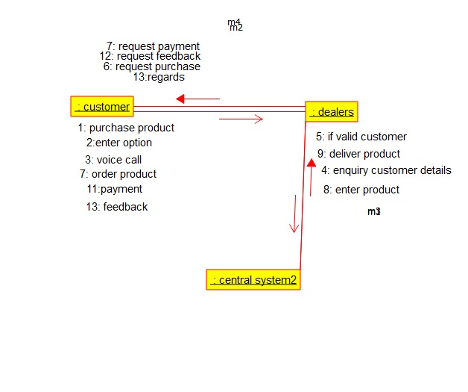

**SEQUENCE DIAGRAM:**

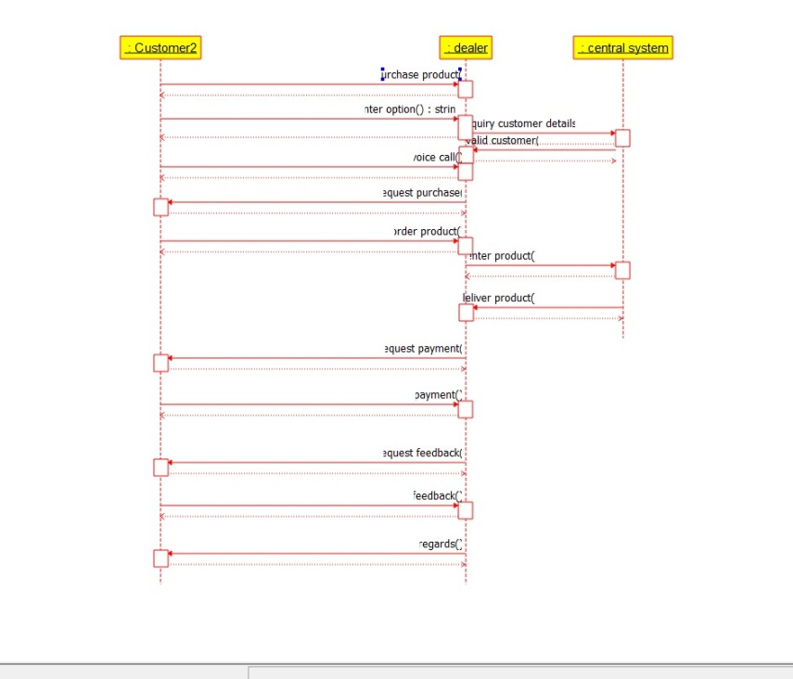

**COMPONENT DIAGRAM:**

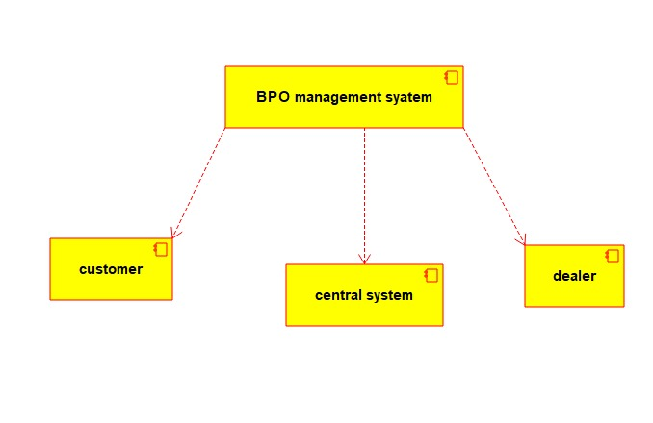

**PROGRAM:**

CUSTOMER:

/**

* Class central_system1

*/

public class central_system1 {

//

// Fields

//

private String store;

private String update;

//

// Constructors

//

public central_system1 () { };

//

// Methods

//

//

// Accessor methods

//

/**

* Set the value of store

* @param newVar the new value of store

*/

private void setStore (String newVar) {

store = newVar;

}

/**

* Get the value of store

* @return the value of store

*/

private String getStore () {

return store;

}

/**

* Set the value of update

* @param newVar the new value of update

*/

private void setUpdate (String newVar) {

update = newVar;

}

/**

* Get the value of update

* @return the value of update

*/

private String getUpdate () {

return update;

}

//

// Other methods

//

/**

* @return String

*/

public String storing()

{

}

/**

* @return String

*/

public String Updating()

{

}

/**

* @return String

*/

public String processing()

{

}

}

/**

* Class customer1

*/

public class customer1 {

//

// Fields

//

private String name;

private String purchase_product;

//

// Constructors

//

public customer1 () { };

//

// Methods

//

//

// Accessor methods

//

/**

* Set the value of name

* @param newVar the new value of name

*/

private void setName (String newVar) {

name = newVar;

}

/**

* Get the value of name

* @return the value of name

*/

private String getName () {

return name;

}

/**

* Set the value of purchase_product

* @param newVar the new value of purchase_product

*/

private void setPurchase_product (String newVar) {

purchase_product = newVar;

}

/**

* Get the value of purchase_product

* @return the value of purchase_product

*/

private String getPurchase_product () {

return purchase_product;

}

//

// Other methods

//

/**

* @return String

*/

public String Payment()

{

}

/**

* @return String

*/

public String Feedback()

{

}

/**

* @return String

*/

public String customer()

{

}

}

DEALER:

/**

* Class central_system1

*/

public class central_system1 {

//

// Fields

//

private String store;

private String update;

//

// Constructors

//

public central_system1 () { };

//

// Methods

//

//

// Accessor methods

//

/**

* Set the value of store

* @param newVar the new value of store

*/

private void setStore (String newVar) {

store = newVar;

}

/**

* Get the value of store

* @return the value of store

*/

private String getStore () {

return store;

}

/**

* Set the value of update

* @param newVar the new value of update

*/

private void setUpdate (String newVar) {

update = newVar;

}

/**

* Get the value of update

* @return the value of update

*/

private String getUpdate () {

return update;

}

//

// Other methods

//

/**

* @return String

*/

public String storing()

{

}

/**

* @return String

*/

public String Updating()

{

}

/**

* @return String

*/

public String processing()

{

}

}

/**

* Class Dealer

*/

public class Dealer {

//

// Fields

//

private String Name;

private String Availability;

//

// Constructors

//

public Dealer () { };

//

// Methods

//

//

// Accessor methods

//

/**

* Set the value of Name

* @param newVar the new value of Name

*/

private void setName (String newVar) {

Name = newVar;

}

/**

* Get the value of Name

* @return the value of Name

*/

private String getName () {

return Name;

}

/**

* Set the value of Availability

* @param newVar the new value of Availability

*/

private void setAvailability (String newVar) {

Availability = newVar;

}

/**

* Get the value of Availability

* @return the value of Availability

*/

private String getAvailability () {

return Availability;

}

//

// Other methods

//

/**

* @return String

*/

public String Payment()

{

}

/**

* @return String

*/

public String Delivery()

{

}

/**

* @return String

*/

public String dealer()

{

}

}